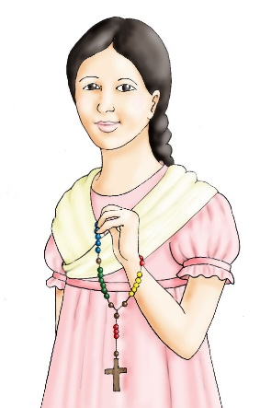
Blessed Pauline Jaricot
Pauline is one of the people who established Missio.
Born in Lyon, France in 1799, she spent her life helping others and sharing the love of Jesus with the world. She encouraged people to raise money for missionaries and to pray for them.
Word Search: Find the following words in the box below:
PAULINE ROSARY
MISSIONARY LYON
PRAYER FRANCE
BLESSED JESUS

U | E | Y | C | X | Z | T | L | N | K | R | P | P | E | X | Q | H | G |  | C | Y
R | E | C | A | X | F | Q | K | C | R | L | B | X | L | P | Q | M | M |  | Z | U
V | W | V | F | U | R | O | N | K | J | K | A | G | Y | N | F | J | W |  | Y | D
M | E | B | W | E | B | H | X | H | E | Q | K | V | H | P | K | N | K |  | E | F
O | X | O | Y | R | N | K | D | A | S | L | B | T | R | J | D | V | S |  | Q | C
V | F | A | E | S | T | X | C | L | U | V | Y | Y | X | G | X | S | U |  | A | O
W | R | Q | W | S | W | A | I | V | S | P | P | T | U | N | E | Y | J |  | T | C
P | A | I | E | N | C | Z | Z | X | C | Z | Q | H | K | L | D | P | G |  | L | O
Y | N | D | A | E | U | C | Y | Z | I | L | M | Z | B | N | U | Z | J |  | M | H
A | C | F | V | L | I | U | S | T | O | O | I | Y | U | D | Q | A | E |  | J | E
S | E | B | Z | B | M | W | E | Y | Q | N | M | Z | K | O | H | U | J |  | V | B
D | G | I | F | F | Y | M | Y | N | B | X | B | Y | S | Q | R | I | L |  | X | J
W | G | I | U | Z | G | F | J | S | Q | R | Q | D | P | S | K | A | L |  | O | B
B | T | X | D | L | K | G | J | B | D | N | O | K | B | G | W | A | T |  | G | A
Y | L | Y | O | N | O | V | K | R | W | V | T | S | P | P | J | H | Z |  | V | N
J | L | N | O | L | M | H | K | O | M | E | O | U | A | X | M | N | O |  | D | O
X | Q | W | B | W | G | O | D | V | A | Z | M | V | G | R | R | J | E |  | E | M
O | K | N | R | A | O | M | I | S | S | I | O | N | A | R | Y | J | F |  | D | D
N | I | K | T | U | O | K | R | B | M | E | F | K | U | R | H | J | O |  | D | V
G | Y | O | N | W | A | P | A | U | L | I | N | E | G | H | N | R | Z |  | H | D
A picture of Blessed Pauline Jaricot for you to colour in:
