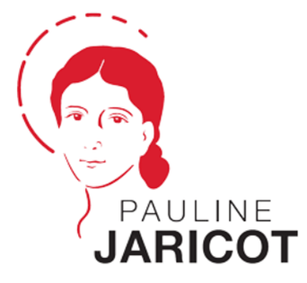

Intercessions and prayers
to mark the Beatification of Pauline Jaricot
on 22 May 2022

Celebrant: As we celebrate the Beatification of Pauline Jaricot, we your priestly people pray for our needs, the needs of our community and the needs of the world.
- For Francis our Pope and N our Bishop and all the Clergy, that the formidable faith of Pauline Jaricot will strengthen them in their ministry and humble leadership.
- For all lay people dedicated to sharing the Gospel of Jesus; that inspired by the missionary Spirit of Pauline Jaricot, they may be given the courage to persevere in their mission.
- For our own parish community; that we may be inspired by the example of those small, prayerful groups that first supported Pauline Jaricot’s vision.
- For those who are suffering, grieving, and anxious: help us to strive together as a parish family to help those in greatest need.
- We pray that the Beatification of Pauline Jaricot may inspire us all to work tirelessly to bring light and hope to dark and challenging situations around the world.

- As Pauline Jaricot led communities in praying the rosary, let us join with our global Catholic family in asking for the intercession of Mary as we pray…
Hail Mary……

Celebrant: Father of Mercies, hear the prayers of your humble people here before you. May we be emboldened by the missionary Spirit shown by Pauline Jaricot and act, in faith, to live out the Gospel message. Amen.

Suggested intercession for promotion in all parishes
Giving thanks for the beatification of Pauline Jaricot this weekend, we pray that like her, we will be inspired to be missionaries in our own lives, and share God’s love with all people.

For more resources and information about Blessed Pauline Jaricot, please visit missio.org.uk/Pauline

