Regional Meeting 2021

*Tuesday, 2 March, held on Zoom*

Notes from the meeting

*A list of those who attended, and those who sent apologies, can be found at the end of this document.*

**Please note: a recording of the meeting can be viewed at** [**https://youtu.be/dP1VVlxY64A**](https://youtu.be/dP1VVlxY64A)

Updates from the dioceses

* Parishes still very much in ‘lockdown’, with lots of funerals taking place.
* Some opening up beginning, with some more services in parts of the countries.
* Wales is in lockdown, with next review on 12 March.
* Relatively few counterfoils being sent in to DDs/Assistant DDs at the moment.
* Evidence of many ‘full’ Red Boxes: need ways to help people bring them to churches to be opened and counted safely.
* Mission Together school visits difficult – visitors going into schools not currently welcome. However, some online assemblies can and have been delivered.
* Shrewsbury: Bishop Mark Davies will celebrate a ‘Missio Mass’, live-streamed from the cathedral, on 12 May at 7pm. Possibly something other bishops could be invited to do.

Updates from Mill Hill

Main change related to the Red Box is that Mill Hill have taken on responsibility for the Parish of Our Lady of Mercy in Sunderland. Fr Christopher Hancock MHM is the parish priest, with Fr Emmanuel Mbeh MHM, and hopefully another Mill Hill Missionary joining them later in the year. The plan is that they will be able to conduct Appeals and Mission Animations within the region from this base.

2020 Overview

Financial Overview

Cedric presented an overview of the finances, which are unsurprisingly down, but not by as much as originally anticipated.

See chart on next page.



2020 Overview: Red Box

* Appeals: 38 were completed in 2020 before ‘lockdown’; over 200 postponed.
* Local Secretaries and communicating with and supporting them became a priority in 2020 (including phone calls, emails, online sessions, and paper mailings).
* Building on the ‘Local Secretary Newsletter’ which goes to all Local Secretaries in the North, a similar (two-page black and white) newsletter is now going to Local Secretaries in the South (with very similar content) along with a eNewsletter (aware that not all LSes are on email).
* Understandably, the last year has resulted in many LSes stepping down from their role. In 2020, 268 retired, with 112 new people taking on the role (not just PPs as interim LS). This compares to 188 stepping down in 2019, and 109 in 2018.
* Unsurprisingly, Red Box income is down in 2020. The biggest decrease was in the Northern dioceses. We have known that we need to focus on the North for a while. With the Mill Hill presence in Sunderland, and the Regional Community Fundraiser based in the North, we will hopefully be able to rebuild support in the northern dioceses.

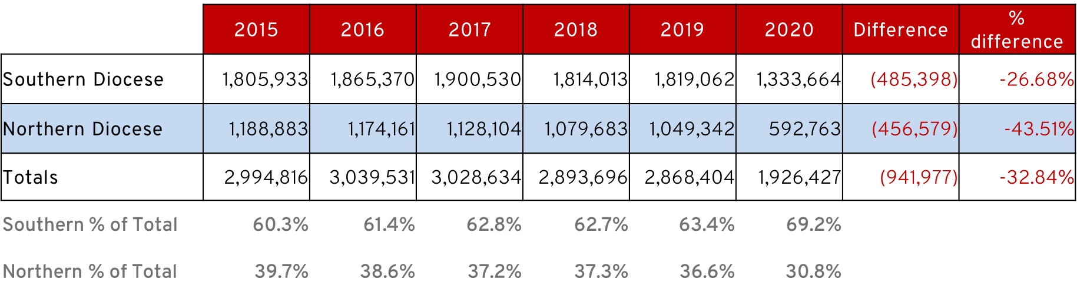

* Breakdowns of parish Red Box income per diocese can be downloaded from [missio.org.uk/DDs](https://missio.org.uk/dds).

Appeals 2021: Discussion

* General consensus that Appeals will not happen before Autumn 2021.
* Advised not to contact parish priests at the moment, but later in the year.
* We can also offer supply cover **this year** (many priests will be grateful to be able to have a weekend away from the parish after 2020), with the understanding that an Appeal in the not-too-distant future will also be arranged.
* We need to ensure the letter/email asking for an Appeal is phrased acknowledging the challenges of the last year.
* When the Appealers meet later in the year as usual, an item to discuss is how to make an Appeal in this environment, especially asking for money at this time.
* Streamlined forms for signing people up to have a Red Box (and/or Direct Debits) need to be ready for when Appeals start again.

Missio Planning 2021

During our review and planning meetings we have identified **5 main areas** that we would like to focus on and develop:

1. **Communication –** Streamlined appeals to coincide with Mission Today**,** focus on sending Mission Today to more people directly if the Local Secretary is not able to deliver them and we have their permission to do so. Aim to sing more people up to our e-newsletter so that we can send follow up appeals and reach those who might not receive Mission Today.
2. **Increased engagement with volunteers** (both in parishes and schools)
3. Continued emphasis on **prayer alongside giving** to our family around the world
4. Developed and implemented **digital strategy** (note online giving in 2020 was up by 70% and we want to maintain this), including social media; and promoting a variety of ways people can give (building on the ‘Let’s think outside the Red Box’ postcards in Summer 2020)
5. **Showing the impact of our work**, with videos in collaboration with other Missio offices

Education/Mission Together

Building on the developed resources in 2020 to support home-learning. Continued resources with a catechetical emphasis, specifically about mission, our role as missionaries, as well as what Missio does. As always, help in sharing the information about the resources is very welcome!

Volunteers

* **Diocesan Mission Team meetings** have developed in some dioceses and now include Local Secretaries and key members of the teams.
* Some dioceses are seeing **World Mission Sunday** in October as a good time to ‘relaunch’ the Missio presence in the diocese.
* **Online training for Local Secretaries** has been held and worked well, with an emphasis on the Local Secretary role as a ministry.
* When face-to-face training and meetings can take place, there will be a mixture of online and face-to-face opportunities.
* **Advent Reflections**, with c.15mins prayerful reflection followed by a time when volunteers can talk with one another, MHMs and Dave/Theresa have gone very well and been appreciated. Currently holding **Lenten Reflections** each Friday. They are also being viewed hundreds of times afterwards on YouTube.
* The **importance of prayer** was emphasised throughout the year, with many people sending in prayer intentions to be held in prayer at Mass, as well as people praying for missionaries and the communities they serve.
* **Local Secretary consultation**: Dave and Theresa are speaking with Local Secretaries and other key contacts (Appealers, Parish Priests, DDs) about the role of the Local Secretary to help us better recruit, train and support them in their role, as well as developing it.
* **Thinking outside the box: two online meetings** have been held to offer support to LSes struggling to collect money at the moment, and to share best practice with one another. A write up of the sessions and ideas has been circulated to LSes and is on the LS page of the website: missio.org.uk/LS

National Council Meeting

There will be no residential meeting this year, due to COVID-19 restrictions.

**8 June 2021 at 10.30am** – online National Council Meeting for all Diocesan Directors

**26-28 April 2022** – residential meeting at Hothorpe Hall

Present

Dcn John Bell (*Hallam*), Fr Paul Boagey MHM (*Appealer*), Fr Gary Brassington (*Clifton*, *Trustee*), Mr Cedric Burke (*Finance Director*), Fr Dermot Byrne MHM (*Appealer*, *MHM British Regional*), Fr Tony Chantry MHM (*National Director*), Dr Theresa Codd (*Regional Community Fundraiser, North*), Ms Claire Colleran (*Mission Together*), Fr Wayne Coughlin (*Northampton*), Fr Patrick Daly (*Brentwood*), Mr Stephen Davies (*Red Box Director*), Mrs Mary Dearden (*Shrewsbury Mission Together*), Mrs Millie Fernandez (*Appeals Coordinator, Province of Southwark*), Fr Tony Grace (*Shrewsbury*), Fr Frank Graham MHM (*Appealer*), Fr Gerry Hastie MHM (*Appealer*), Fr Kevin Hughes MHM (*Appealer*), Dcn Tom Kavanagh (*Southwark*), Fr Jan Klaver MHM (*Appealer*), Canon Michael Loughlin (*Middlesbrough*), Fr Emmanuel Mbeh MHM (*Appealer*), Ms Siobhan McLoughlin (*Appealer* *Coordinator, North East*), Fr Vincent Oates MHM (*Appealer*), Fr Brian Oswald MHM (*Appealer*), Fr Bernard Phelan MHM (*Appealer*), Ms Nicky Pisa (*Director Fundraising and Communications*), Fr Greg Price (*Hexham and Newcastle, Trustee*), Fr Carlos Quito (*Westminster*), Mrs Margaret Tackney (*Appeals Coordinator, Province of Westminster*), Mrs Joanne Walsh (*Appeals Coordinator, North West*), Canon Paul Watson (*Menevia*), Mr Dave Wheat (*Regional Community Fundraiser, South*).

Apologies

Fr Philip Baptiste (*Westminster Mission Together*), Dcn Duncan Brown (*Arundel and Brighton*), Br Eddie Slawinski MHM (*Appealer*), Mr Mugeni Sumba (*Appealer*).